Prostate gland and Bulbourethral Glands

Prostate gland

Etymology
Greek prostatēs ‘one that stands before’, from pro ‘before’ + statos ‘standing’.

Location
- In lesser pelvis
- Above urogenital diaphragm
- Below neck of bladder
- Embraced by levator ani
- In front of rectal ampulla

Measurements
- 4 cm
- 3 cm
- Anteroposterior length – 2 cm
- Weight – 17 to 19 g
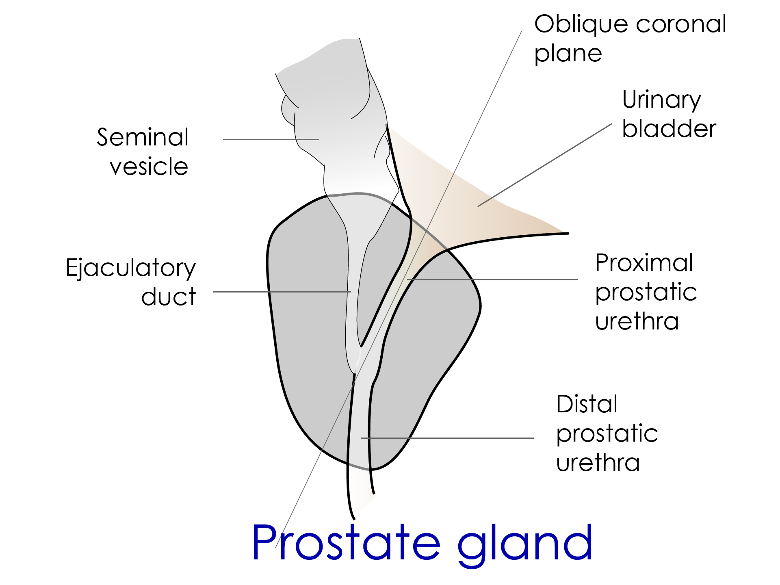

Prostate gland

Fixation and Suspension
- Puboprostatic ligaments
- Urogenital diaphragm
- Bladder
- Fascia of Denonvilliers

Coverings
- True capsule - condensation of the connective tissue aroound the gland
- False capsule

False capsule
- Anterior – puboprostatic ligament
- Posterior – fascia Denonvillier’s

Prostatic plexus of veins
- Are located between the true and false capsule
- While removing the gland via transurethral method - more damage to these plexuses is anticipated
- Comparison to thyroid gland
- The venous plexus located within the true capsule and gland is removed with the capsule
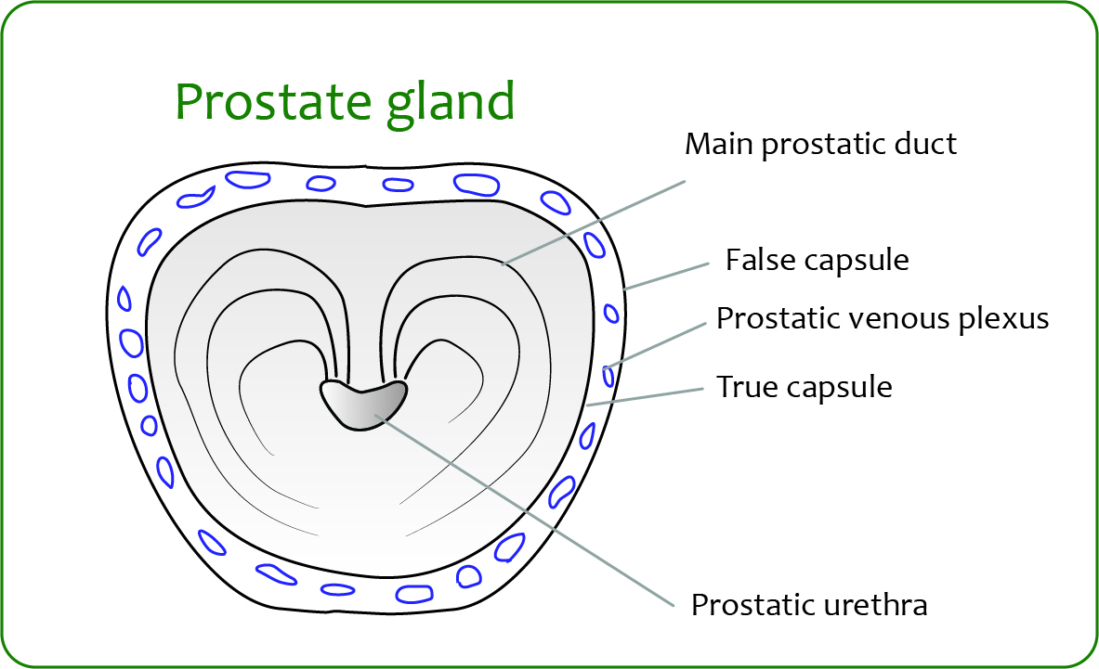

Parts – apex and base
- Apex – below
  - Urogenital diaphragm
- Base – above
  - Surrounds neck of bladder
  - Urethra at – antr 1/3rd and postr 2/3rd of gland

Parts – surfaces
- One posterior, one anterior, and two inferolateral
- Posterior surface - bilaminar fascia of denonvilliers
- Palpated by digital rectal examination
- Anterior surface - between the apex and the base
- Puboprostatic ligaments
- Right and left inferolateral surfaces - fixed to the levator
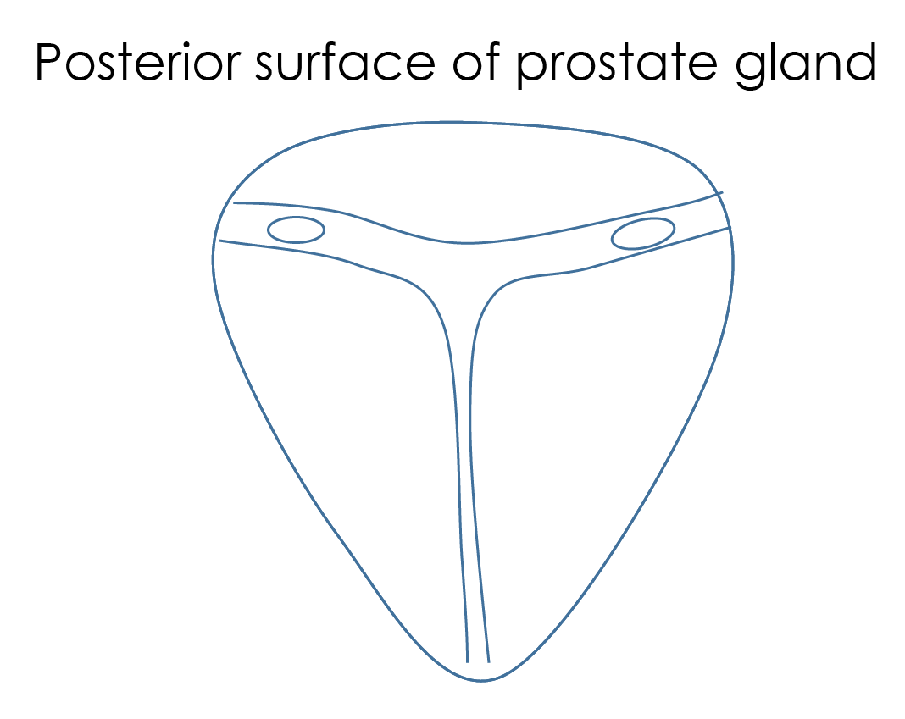

Palpated digitally
Related to the rectum
Palpated by digital per rectal examination

Parts – apex and base

Location
Anatomically – 2 lateral + 1 medians
Surgically
Median
- Anterior
- Posterior
- 2 lateral

McNeal's 4 anatomic regions of the prostate

Peripheral
- ~75% of the gland
- Surrounds the central zone and urethra
- Its glands drain into prostatic urethra

Central
- ~25% of the gland
- Envelops the ejaculatory ducts

Transitional
- < 5% of the glandular prostate
- two-minute glandular regions
- lateral to the preprostatic sphincter
- directly related to the proximal urethral segment

Stroma
- Anterior fibromuscular stroma is nonglandular
- Continuity with the detrusor muscle of the neck of the urinary bladder
- Represents the periurethral gland region

Significance of McNeal's lobation
- Most carcinomas develop in the peripheral zone
- Transitional zone - Exclusive site of origin of benign prostatic hypertrophy
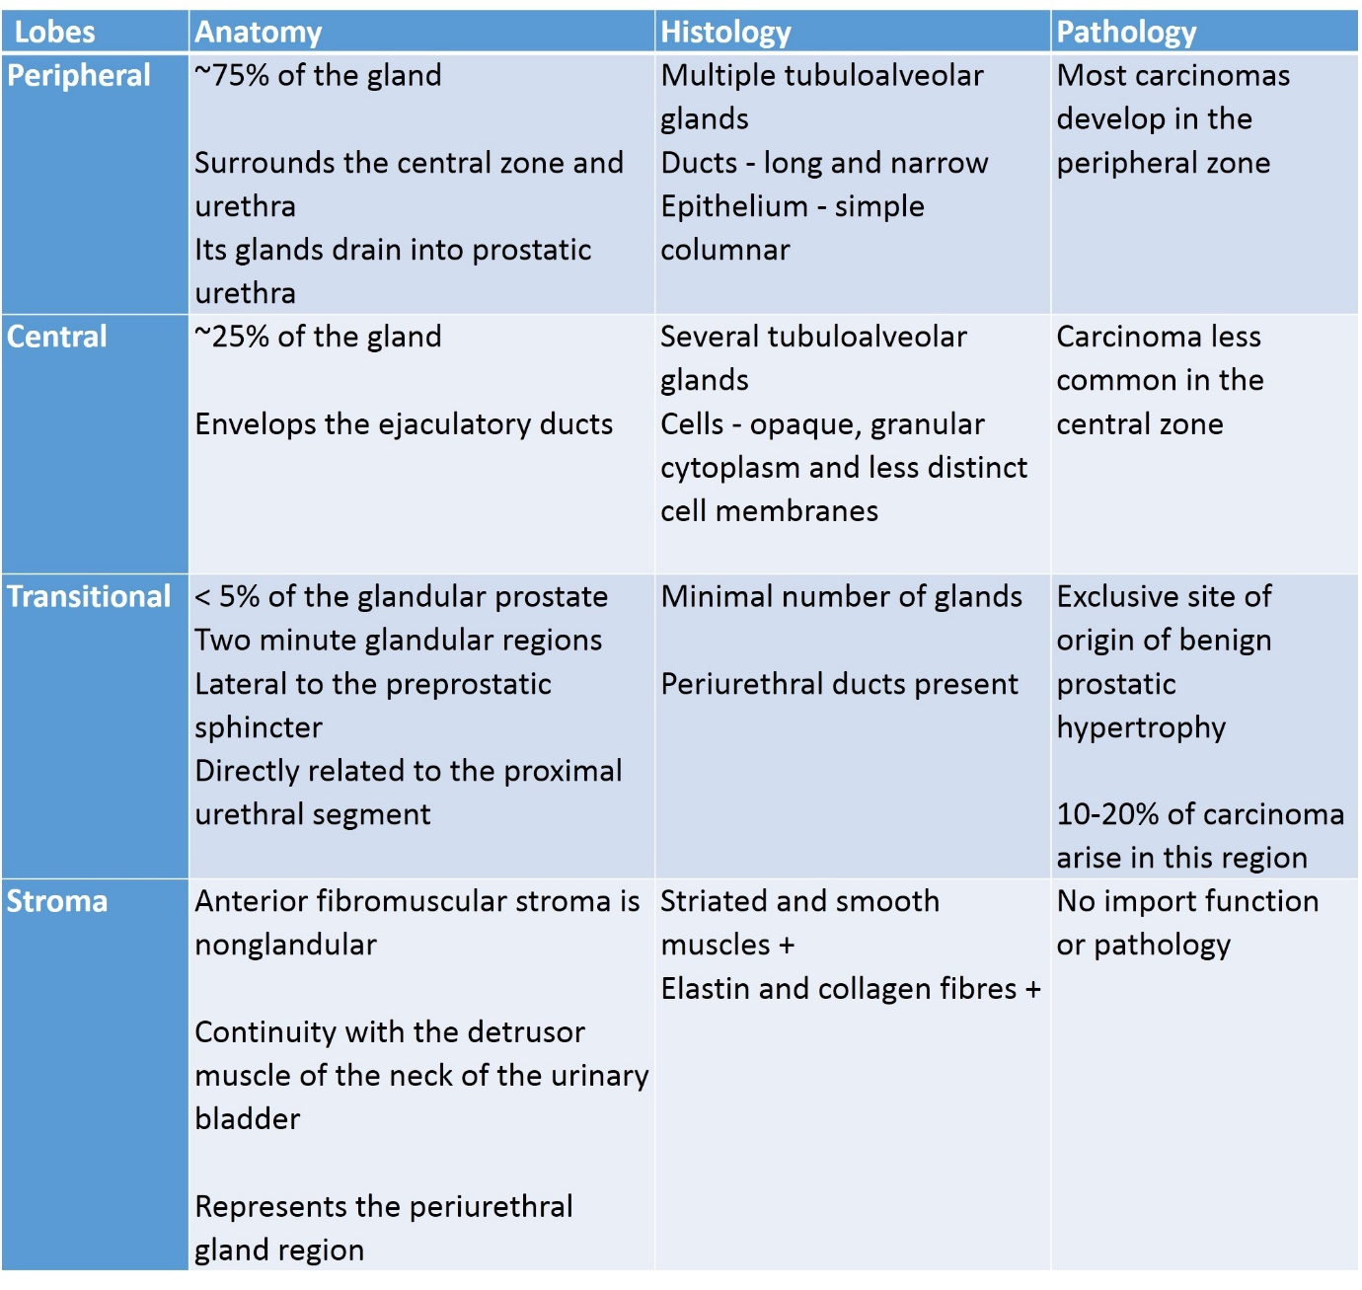

Blood supply of prostate

Arteries
- inferior vesical artery
- Divides into central branches and peripheral branches
- internal pudendal
- middle rectal arteries

Veins
- Prostatic plexus located between prostate gland and prostatic sheath
- Communications - prostatic plexus communicates with internal iliac venous system and presacral veins. They also communicate with extradural venous plexus of Batson
- CA prostate can spread to the spine and to skull through this route
- The deep dorsal vein of penis reaches prostatic plexus after passing through cleft between the pubic arcuate ligament and transverse perineal ligament of the urogenital diaphragm

Lymphatics
Drain to internal iliac lymph nodes and occasionally to external iliac lymph nodes

Innervation
Sympathetic nerves - L1 and L2 intermediary columns reach via - preaortic and pelvic plexus.
They innervate smooth muscles of seminal vesicle, ejaculatory ducts and prostatic glands
Parasympathetic nerves - S2, S3, and S4 reach via - pelvic ganglia and periprostatic ganglia

Histology
- Glandular epithelium is simple columnar or pseudostratified
- Lumina of the acini are normally wide and typically irregular because of the protrusion of the epithelium-covered connective tissue folds
- Some of the glandular acini contain proteinaceous prostatic secretions
- Fibromuscular stroma consisting of smooth muscle bundles and the connective tissue fibers blend together

Corpora amylacea
- Small hyaline masses
- Derived from degenerate cells or thickened secretions
- Occur more frequently with advancing age

Physiology
- Secretes a milklike alkaline fluid.
- Important for the fertilization of the ovum

PSA - Prostate Specific antigen
PSA is produced for the ejaculate, where it liquefies semen in the seminal coagulum and allows sperm to swim freely.
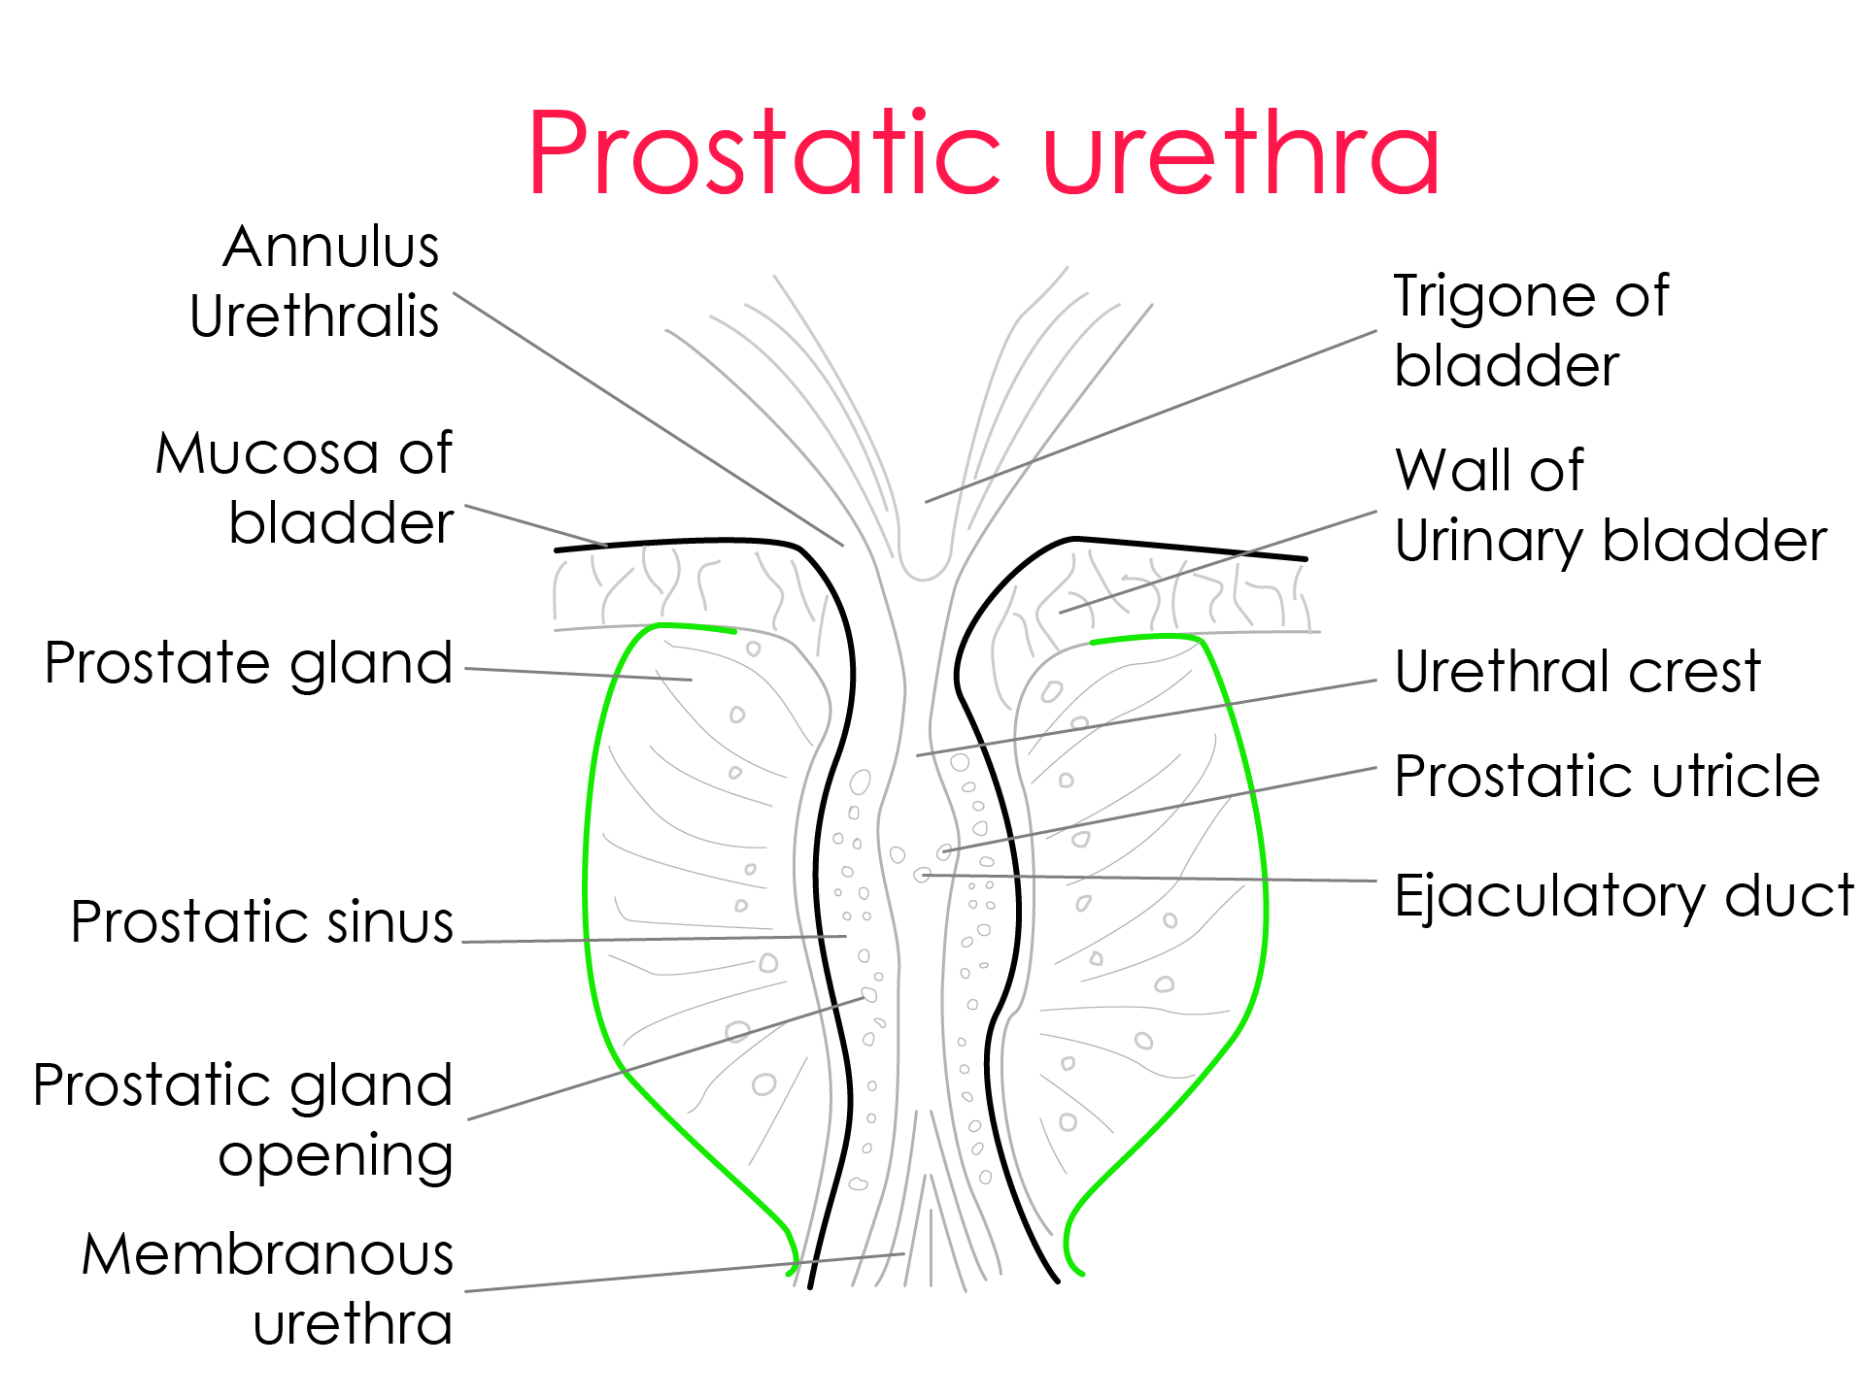

Prostatic Urethra
- Urethral crest
  - Longitudinal fold of mucosa in the posterior part of prostatic urethra
  - Extends from uvula of the bladder
- Verumontanum (colliculus seminalis)
  - Round elevation over the urethral crest
- Prostatic utricle or uterus masculinus
  - Small culd-de-sac at the verumontanum
- Orifices of the ejaculatory ducts
- Prostatic sinus
  - Linear depression on either side of the urethral crest
  - Into the sinus, many prostatic ducts open

Applied aspects

Clinical examination of prostate gland - Digital per rectal examination
The index finder of the examiner is introduced through the anal orifice. The prostate gland is felt anteriorly with the pulp of the index finger.
Patient can be either in dorsal lithotomy position or the lateral recumbent position
Each lobe of the prostate is examined
Normal prostate has consistency of thenar eminence when the thumb and little finger is approximated
Any hardness, abscess, nodular consistency or increased in size is abnormal

